GOVERNMENT POLYTECHIC, SHORAPUR,
KARNATAKA 585224
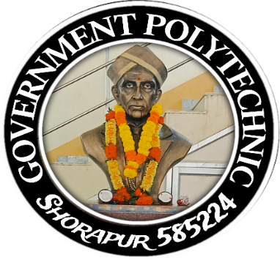
DEPARTMENT OF COMPUTER SCIENCE AND ENGINEERING
CERTIFICATE
The certified Diploma Portfolio report on “Software Engineering Principles
and Practices” is a bonafied work carried out by ___________________
Reg. No: _____________ , student of the 4th semester Diploma, Department of
Computer Science & Engineering, Government Polytechnic, Shorapur affiliated to
DCET Bengaluru during the academic year 2025-26. The report has been thoroughly
Reviewed and it is approved that report satisfy the necessary academic
Requirements prescribed for Diploma.

_ _ _ _ _ _ _ _ _ _ _ _ _ _ _ _ _ _ _ _ _ _ _ _ _ _ _ _ _
Signature of Guide Signature of HOD Signature of Principal
Miss. Pallavi Dhargi Mrs. Renuka Mr. Srikant G.K

Examiner I Examiner II

Signature
With date:

Name:

